**{{name}} {{date}}**

**Emp. ID:- {{emi}}**

TO WHOMSOEVER IT MAY CONCERN

This is to certify that {{name}} was working with **Precesion Staffing** from {{jdate}} – {{rdate}}

The individual's designation at the time of departure was **{{des}}**.

H{{x}} brief experience summary during the stay with the organization is given below:

* Manage the full accounts receivable process for clients in the US.
* Collaborate with Finance leads and AR teams to ensure accurate billing.
* Drive strategic initiatives to improve collections and cash flow.
* Develop action plans for reducing overdue accounts and managing risk.
* Work with internal teams to resolve billing discrepancies and issues.
* Use AR software and tools to track and manage account balances.
* Handle client communications, resolve issues, and provide updates as needed.

During this tenure we found h{{x}} performance and conduct to be satisfactory. We wish him the very best in h{{x}} future endeavors

This letter is issued on the request of the employee

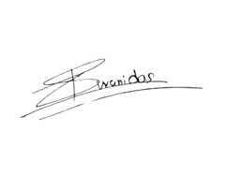

**Yours truly,**

(Authorized Signatory)

Shivani Das

Human Resources-Manager